ETHNOMYCOLOGY
EBOT F336, ANTH F336
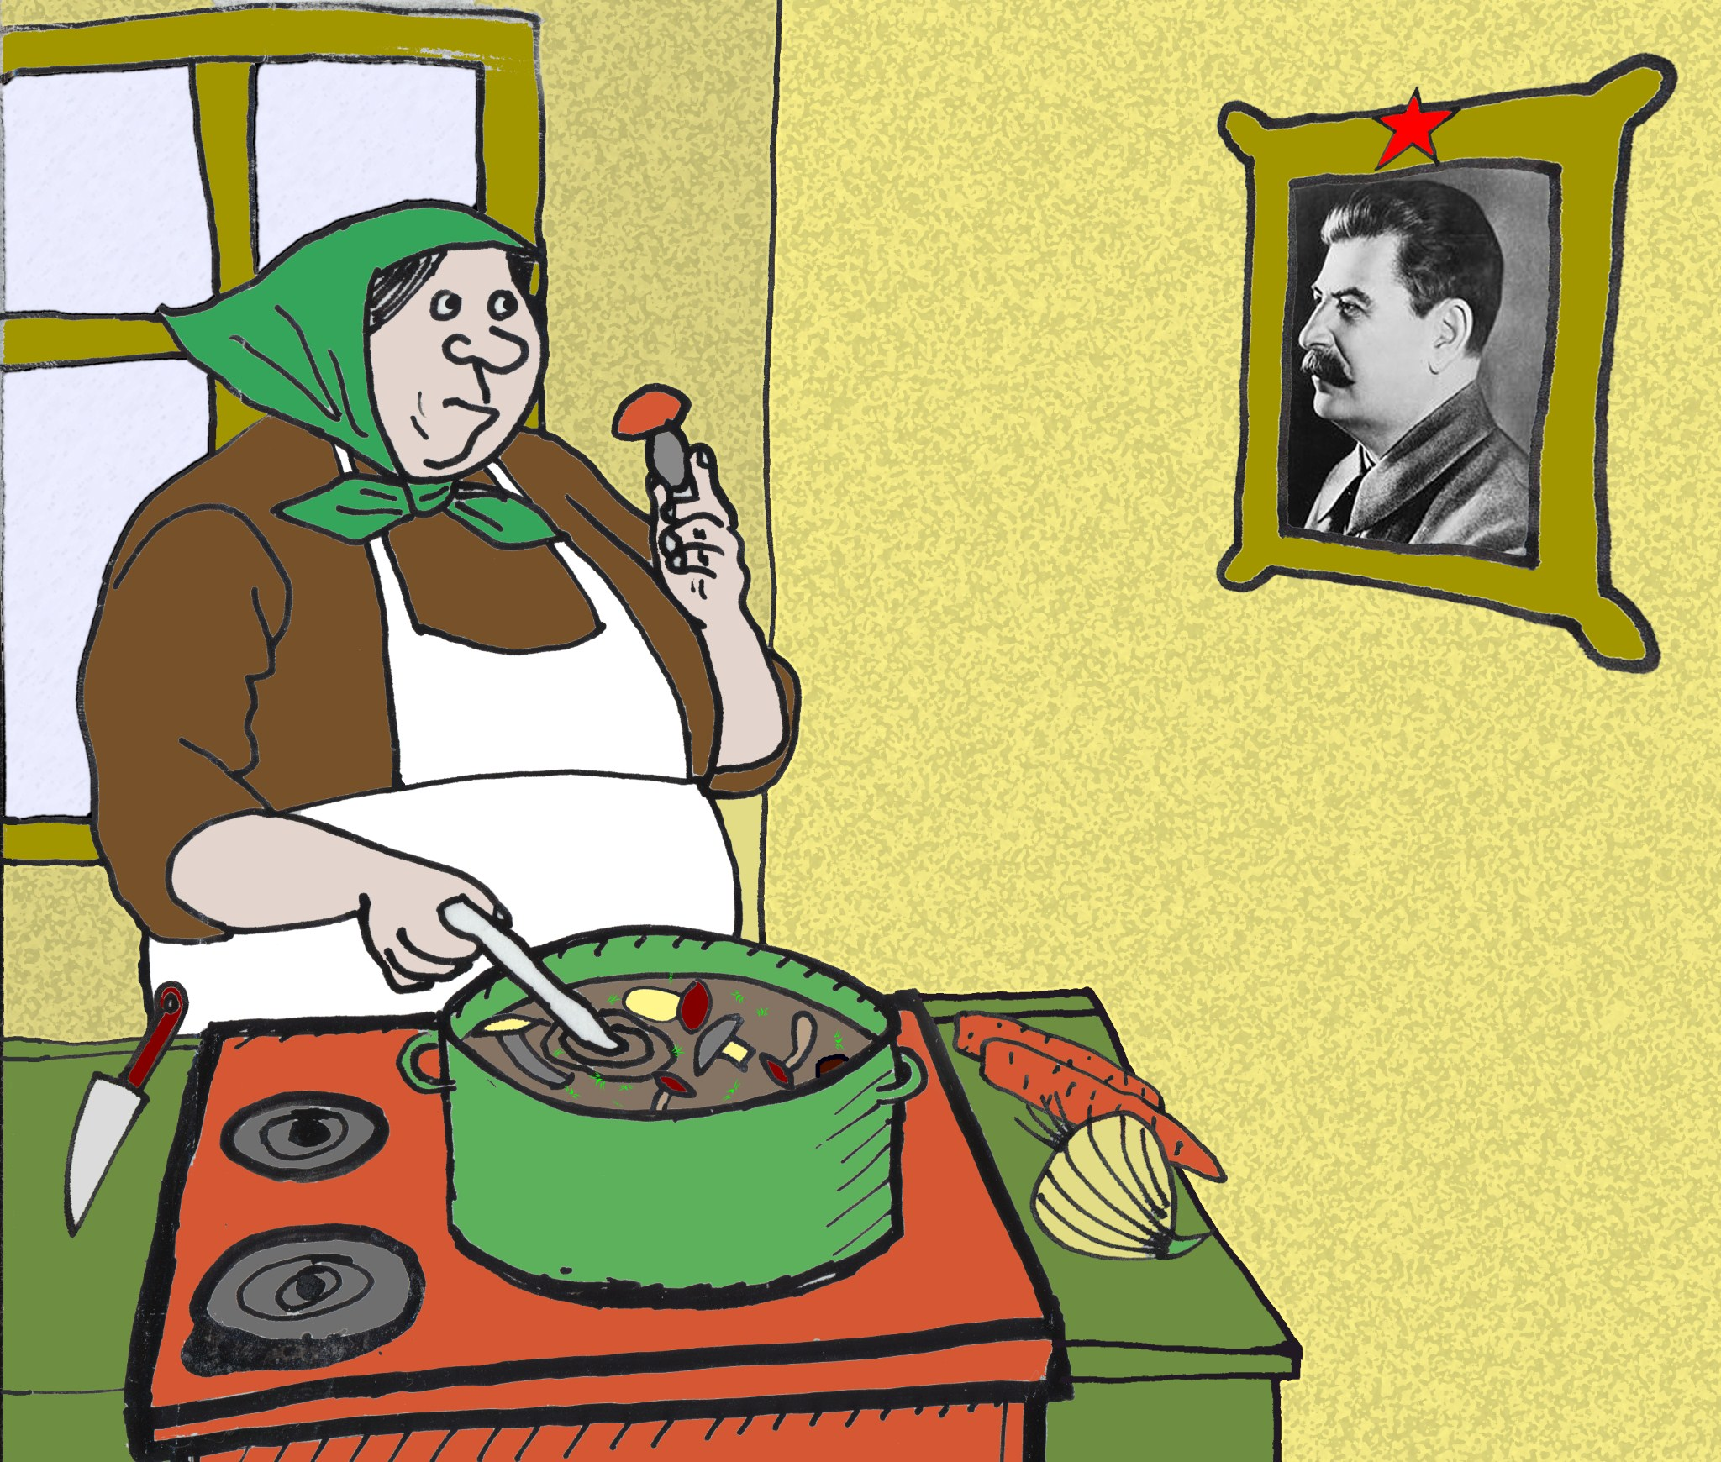
“Always Boil First,” by Igor Pasternak, Fungi, Fall 2013
Spring 2022, 3 Credits, Wednesday 6-9pm, via zoom

Instructors: Sveta Yamin-Pasternak (syamin@alaska.edu)
Igor Pasternak (gipasternak@alaska.edu)

Teaching Assistant: Nell Bishop <ebishop9@alaska.edu>

Instructor Information:
Professors Igor Pasternak and Sveta Yamin-Pasternak teach at the University of Alaska Fairbanks Department of Anthropology, Department of Art, and Ethnobotany Program; we are also members of the research faculty at the Institute of Northern Engineering. Ethnomycology has been one of our main fields of study over the last twenty years.

Course Prerequisites:
ANTH 100X or EBOT 100 or Instructor permission

Course Description
Ethnomycology is concerned with the roles of fungi in the human social experience. Ethnomycological research asks how the members of the kingdom Mycetae, the “third kingdom” (so named for being neither animals nor plants), play into the human dietary, medicinal, spiritual, recreational, economic, and cognitive domains. A broad view of the field considers human engagements with all types of fungi: those that produce fleshy mushrooms as well as slime molds, yeasts, rusts, smuts, and the organisms that humans and other beings experience as fungal infections. A more bounded definition focuses on the beliefs and practices surrounding the fungi that produce fleshy mushrooms. Given the relevance of fungi in all ecosystems and many concepts and practices found in cultures and societies around the world, ethnomycology reaches broadly across domains of social-ecological research.

Course Goals
As an introductory overview of ethnomycology, the course aims to provide students with greater awareness and appreciation of the ways in which the study of the human relationships with fungi can shed light on broader cultural processes and social-ecological interactions. An inherently multidisciplinary field, Ethnomycology is a social science that integrates perspectives of many different types of researchers, including anthropologists, cultural geographers, sociologists, art historians, linguists, psychologists, and political scientists. It also reaches into areas of life sciences and physical sciences, humanities, and fine arts, as a number of practitioners in these fields have explored connections between people and fungi. This course examines works of key contributors to ethnomycology – the contributors whose ideas have played an important role in establishing and developing the field. The lecture and reading materials discuss the roles of fungi in food, medicine, art, commerce, recreation, spiritual life, and various utilitarian applications. The course features examples of human-fungi interactions from societies around the world, including Alaska and other high latitude regions.

Learning Outcomes
Upon successful completion of the course, students will be able to apply:
- foundational ideas, discoveries, social-cultural processes, and contemporary influences that shape the field of ethnomycology,
- crosscultural variation and historical change in how humans utilize and interact with mushrooms and other fungi,
- current research directions and questions in ethnomycology and related fields, - key methodologies and analytical tools needed to design and carry out ethnomycological research,
- resources such as library and museum collections, web-based sources, and professional and amateur organizations, helpful in the further explorations in ethnomycology,
- major transformative perspectives from ethnomycology and related fields, which help us think critically about the differences in cultural assumptions and worldviews that shape our social relationships.
Student performance in the exams and writing assignments serve as a measure of the student success.

Texts
Required:
Bone, Eugenia 2011 Mycophilia: Revelations from the Weird World Of Mushrooms. Rodale Publishers.
Letcher, Andy 2007 Shroom: A Cultural History of the Magic Mushroom. HarperCollins Publishers.
Recommended:
Tsing, Anna, 2021 The Mushroom at the End of the World: On the Possibility of Life in
Capitalist Ruins. Princeton Press.
This book is recommended for students interested in applying advanced contemporary
theory and methods in trans-disciplinary scholarship to raise and address innovative and
provocative questions in the field.

Other required reading materials listed in the Course Calendar are distributed in electronic format via Blackboard.

Course Structure and Policies
Delivery Method and Required Technology Access:
The class meetings are facilitated through a synchronous delivery via Zoom. All reading materials with the exception of the aforementioned books will be made available via Blackboard.

The course grade is determined based on the following criteria:
- Class participation, including sharing knowledge and experience and contributing to discussions with fellow students and instructors in ways that reflect familiarity with the reading and lecture material covered to date, is worth 25% of the course grade
- Ethnomycological Autobiography assignment is worth 20% of the course grade
- Midterm exam is worth 25% of the final grade
- Final exam is worth 30% of the final grade

Completing the Ethnomycological Autobiography assignment involves writing a 3-page double-spaced paper that provides an overview of the student experiences with fungi, connected to these five domains: food, medicine, spirituality, household uses, and broader relationships with the social and physical environments in which they have lived. The assignment aims not to evaluate the student erudition in the field, but to explore the individual experiences stemming from the social and cultural background of each student.

The two exams, a midterm and a final, consist of essay questions that aim to assess the student understanding of the lecture and reading material. Exam questions and guidelines will be distributed via Blackboard two weeks ahead of the deadline.

Letter grades for the course are assigned as follows:
A+ = 97-100%; A = 92-96.5%; A- = 90-91.5%;
B+ = 87-89.5%; B = 82-86.5%; B- = 80-81.5%;
C+ = 77-79.5%; C = 72-76.5%; C- = 70-71.5%;
D+ = 67-69.5%; D = 62-66.5%; D- = 60-61.5%

Student Support
Students are encouraged to become familiar with the UAF student support services available at regional campuses and online. The UAF main website provides links to the Academic Advising Center, Writing Center, campus libraries, Office of Information Technology, Student Activities Office, Center for Health and Counseling, and e-Learning and Distance Education. Students should feel comfortable to consult the appropriate service for assistance with schoolwork, research, personal wellness, and adequate access to resources. The instructors are happy to assist with questions relevant to the course. Students may contact the instructors via email and also set up appointments for telephonic or office meetings. The instructors work with the Office of Disabilities Services (UAF Main Campus 208 Whitaker Building, 474-5655) to help facilitate best possible accommodation for students with disabilities.

Course Calendar
This is our main route for the semester. Students should expect some modifications to accommodate the emerging class dynamics and the interests and needs expressed as we advance in the course. All changes in the schedule and reading calendar will be announced in class and posted in Announcements on the course Blackboard page within sufficient timeframe to complete the reading.

Core Deadlines and Deliverables:
Ethnomycological Autobiography assignment: January 26
Midterm: March 23
Final: 8:00 - 10:00 p.m., Wednesday, April 27
Weekly: joining every class meeting having read the assigned materials is a must.

Week 1 January 12
COURSE INTRODUCTION
Students receive instructions for the assignment “Ethnomycological Autobiography.”

Week 2 January 19
DEFINING THE THIRD KINGDOM:
- how fungi are understood in different knowledge systems, including mycological science

Assigned book chapters:
Mycophilia: “Introduction”
Shroom: “The Mushroom People”

Assigned electronic articles:
Aptroot, Andre et al
2014 Rapid Assessment of the Diversity of “Vehiculicolous” Lichens on a Thirty Year Old Ford Bronco Truck in Central Puerto Rico, Fungi 7(2-3): 23-27
Benjamin, Denis
2014 A Lexicon for Mushroom Tasting, Fungi 6(5): 16-17
Dugan, Frank
2014 Yeasts: What's in a name? A brief reconnaissance and sampling of literature, Fungi 6(4): 46
Hallock, Robert and Maura LaBrecque
2014 Distinct Odors of Mushrooms and an Odor Wheel to Categorize Them Fungi 6(5): 18-22
Kay, Richard
2013 What’s in a Name? A Philological Foray. Explorations of the Scientific Names of Select Genera of Fungi, Fungi 6(2): 4-5
2012 What’s in a Name? A Philological Foray. Explorations of the
Scientific Names of Select Genera of Fungi, Fungi 5(5): 4-5

Week 3 January 26 Assignment “Ethnomycological Autobiography” is DUE before the start of the class meeting, to be submitted via email.

ETHNOMYCOLOGY AS A FIELD OF STUDY
- key contributors, historical and contemporary perspectives

Assigned book chapters:
Mycophilia: “Forays and Festivals”
Shroom: “Science and Magic”

Assigned electronic articles:
Tsing, Anna
2013 Dancing the Mushroom Forest, Philosophy, Activism, Nature 10: 6-14
Yamin-Pasternak, Sveta
2011 Ethnomycology: Mushrooms in Cultural Entanglements,
Ethnobiology, a Textbook, Adnerson, E.N., Pearsall, D., Hunn, E., and
Turner, N., eds. Wiley Blackwell Publishers

Week 4 February 2
LEARNING ABOUT MUSHROOMS:
- critical overview of literature, online sources, professional and amateur organizations, community events

Assigned book chapters:
Mycophilia: “Conferences and Collectors”
Shroom: “The Archaeology of Ecstasy”

Assigned electronic articles:
Arora, David
1999 The Way of the Wild Mushroom California Wild 52: 8-19
Bunyard, Britt
2011 Psilocybe 101: A Primer on Magic Mushrooms and Related Little
Brown Mushrooms Fungi 4(3): 43-48
Money, Nicholas
2014 Circus Fungorum: The Aesthetics of Fungal Movement Fungi 6(5): 36-39
Stamets, Paul
2013 Maitake: The Magnificent Dancing Mushroom, Fungi 6(3): 12-14.
Velinga, Else
2012 Fruitbodies – A Selection of the Mycological Literature, Fungi 5(5):
15-16

Week5 February 9
MYCOPHAGY: FUNGI IN WORLD CUISINES
- culinary uses of wild mushrooms, common cultivated varieties, lactic bacteria and yeasts in baking, fermentation, and distilling

Assigned book chapters:
Mycophilia: “Mutualists, Decomposers, and Parasites”
Shroom: “Much Disordered”

Assigned electronic articles:
Bunyard, Britt
2013 Tokays and Sauternes, Fungi 6(3): 31-32 Buyck, Bart
2008 The edible mushrooms of Madagascar: an evolving enigma,
Economic Botany 62(3): 509-520
Cook, Langdon
2013 Fire on the Mountain: The Secrets of Burn Morel Hunters, Fungi 6(4): 34-37
Rubel, William and David Arora
2008 A Study of Cultural Bias in Field Guide Determinations of Mushroom Edibility Using the Iconic Mushroom, Amanita muscaria as an Example, Economic Botany 62(3): 223-243.

Week 6 February 16
Continued MYCOPHAGY: FUNGI IN WORLD CUISINES
- culinary uses of wild mushrooms, common cultivated varieties, lactic bacteria and yeasts in baking, fermentation, and distilling

Assigned book chapters:
Mycophilia: “Hunters, Gatherers, and Thieves” Shroom: “Feasts and Revelations”

Assigned electronic articles:
Benjamin, Denis
2013 A Proposed Classification for the Bolete Harvest and Its Uses, Fungi
6(4): 27-30
Hufford, Mary
2006 Molly Mooching on Bradley Mountain: The Aesthetic Ecology of Appalachian Morels, Gastronomica 6(2): 49-60
Jonsson, Maria
2011 Swedish Mushrooms: Part of a National Heritage, Fungi (3): 51-55
Sitta, Nicola and Marco Floriani
2008 Nationalization and globalization trends in the wild mushroom commerce of Italy with emphasis on porcini (Boletus edulis and allied species), Economic Botany 62(3): 307-322.

Week 7 February 23
Continued MYCOPHAGY: FUNGI IN WORLD CUISINES
- culinary uses of wild mushrooms, common cultivated varieties, lactic bacteria and yeasts in baking, fermentation, and distilling

Assigned book chapters:
Mycophilia: “The Exotics” and “Truffles”
Shroom: “Wasson”

Assigned electronic articles:
Nicholson, Michael and Brooke Pearson
2014 Variables Influencing Viability of Brewer’s Yeast, Fungi 7(1): 23-27
Rogers, Robert
2013 Agarikon, Ghosts of the Pacific Northwest, Fungi 6(4): 20-23 Shavit, Elinoar
2008 Truffles roasting in the evening fires: pages from the history of desert truffles, Fungi (1): 18-23.
Winkler, Daniel
2013 Truffles of The Pacific Northwest, Fungi 6(4): 16-19

Week 8 March 2
MUSHROOMS FOR HEALTH AND HEALING:
- ethnomedicine and mycopharmacology

Assigned book chapters:
Mycophilia: “Fungi that Make You Well and Fungi that Make You Sick” and “The
New Superfood”
Shroom: “The Fly Agaric”

Assigned electronic articles:
Beug, Michael:
2012 A Reflection on Medicinal Mushrooms, Fungi 5(1): 38-39
McFarland, Joseph:
2012 Is there a Responsible Way to Harvest Chaga? Fungi 5(3): 8-9
Pilz, David
2012 Chaga Harvesting in the Land of the Siberian Tiger, Fungi 5(3) Rose, David
2012 The Stinkhorn Monologue 5(1): 23-31
Shepard, Glenn H Jr., Arora, David and Aaron Lampman
2008 The Grace of the flood: classification and use of wild mushrooms among the highland Maya of Chiapas. Economic Botany 62(3): 437-470
Spinosa, Ron
2012 The Chaga Story 5(3): 22-26
Spinosa, Ron and Britt Bunyard
2012 No, That’s Not Chaga 5(3): 45-47

Week 9 Spring Break, no classes!

Week 10 March 16
CRAFTY APPLICATIONS:
- fungi in fabric dyes, woodworking, gardening, and household applications

Assigned book chapters:
Mycophilia: “All About Buttons” and “Mycotechnologies”
Shroom: “Soma” and “Chemistry and Conspiracy”

Assigned electronic articles:
Allen, Alissa
2014 Getting Started with Lichen Dyes, Fungi 7(2-3):66-69
Lucking, Robert and Thorsten Lumbsch, 2014 Lichens: Fungal Farmers, Fungi 7(2-3): 6-14
McFarland, Joseph
2014 More Details about Fire and Fungi, Fungi 7(1):41-44
Rhodes, Chris
2014 Mycoremediation (Bioremediation with Fungi) – Growing Mushrooms to Clean the Earth. A mini-review, resilience.org
Rice, Miriam
1980 Mushrooms for Color, Mad River Printing

Week 11 March 23
Midterm Exam is Due before the start of the class meeting, to be submitted by email.

FUNGI AND EXPRESSIVE CULTURE:
- visual, literary, and performance art inspired by the third kingdom

Assigned book chapters:
Shroom: “Academic Exercise” and “High Priests”

Assigned electronic articles:
Rose, David
2009 Ethnopetics: Somapoetics, Fungi 2(2):8-10, 41-44.
2008 A Plurality of One: John Cage and the People-to-People Committee on Fungi, Fungi 1(4): 25-35
- Auricularia auricular, Anti-Semitism, and Political Mushrooms, Fungi 1(1): 12-17
Schaechter, Elio
- Mushroom sellers in Renaissance and Baroque paintings. Fungi 2(1): 12-13
Stoddard-Hayes, Marlana
2014 Spore Prints as Art, Fungi 7(1):22
2011 Spore Prints as Art, Fungi 4(3):42

Week 12 March 30
SOCIAL AND ECOLOGICAL RELATIONSHIPS
- economic, recreational, and spiritual values connected with fungi

Assigned book chapters:
Mycophilia: “Shrooms”
Shroom: “Ripples and Waves”

Assigned electronic articles:
Dugan, Frank
2012 Yippie Yi Yo, Mycota Ki Yay, Fungi 5(1): 6-19
Saito, Haruo and Mitsumata Gaku
2008 Bidding Customs and Habitat Improvement for Matsutake
(Tricholoma matsutake) in Japan, Economic Botany 62(3): 258-268.
Winkler, Daniel
2008 Yarsa Gunbu (Cordyceps sinensis) and the Fungal Commodification of the Rural Economy in Nepal, Economic Botany 62 (3): 291–305

Week 13 April 6
Continued SOCIAL AND ECOLOGICAL RELATIONSHIPS
- economic, recreational, and spiritual values connected with fungi

Assigned book chapters:
Mycophilia: “The Superorganism”
Shroom: “Ripples and Waves” and “Underground Overground,”

Assigned electronic articles:
Lincoff, Gary 2011 Psilocybin – Its Use and Meaning, Fungi 4(3): 20-23, 50
Beug, Michael W.
2011 The Genus Psilocybe in North America, Fungi 4(3): 6-17
2011 Psilocybin – History, Personal Stories and Potential Future, Fungi 4(3):
31-40
Rose, David
2011 Psilocybe and Psychedelics; Or, Timothy Leary in Baltimore, Fungi
4(3): 24-30

Week 14 April 13
Continued SOCIAL AND ECOLOGICAL RELATIONSHIPS
Students receive questions for the take-home final exam
- economic, recreational, and spiritual values connected with fungi

Assigned book chapters:
Shroom: “Ripples and Waves,” “Underground Overground” and “The Elf-Clowns of Hyperspace”

Assigned electronic articles:
Guzman, Gaston
2008 Hallucinogenic mushrooms in Mexico: an overview. Economic
Botany 62(3): 404-412.
Saar, Maret
1991 Ethnomycological Data from Siberia and Northeast Asia on the
Effect of Amanita muscaria, Journal of Ethnopharmacology 31: 157-173.

Week 15 April 20
CLOSE TO HOME
- mushrooming in our region(s), changing perspectives, emerging uses

Assigned book chapters:
Shroom: “Muck and Brass,” and “Epilogue: Love on a Puffball”

Assigned electronic articles:
Benjamin, Dennis
2011 Should the Harvesting and Selling of Wild Mushrooms Be Regulated? Fungi 4(2):41-43.
Blanchette, Robert A., Renner, Caroline C., Held, Benjamin W., Enoch, Carrie and Sarah Angstman
2002 The current use of Phellinus igniarius by the Eskimos of Western Alaska, Mycologist 16: 142-145.
Pleninger, Diane B
2009 Iqmiq; Troubled Child of Phellinus and Nicotiana, Fungi 2(2):2-6, 4748
Yamin-Pasternak, Sveta
2013 The Unconditionally Loved Conditional Edibles or How to Ruin a
Morel, Fungi (6)1:12-16
2008 A Day that Feeds the Year: Ethnography of Mushrooming in the
Russian Arctic, Fungi 2(2) 49-57
2007 An Ethnomycological Approach to Land Use Values in Chukotka,
Etudes Intuit Studies 31(1-2): 121-141

Final Exam Meeting 8:00 - 10:00 p.m., Wednesday, April 27
WRAPPING UP THE COURSE -reflections and anticipation for the foraging season
Congratulations on completing the semester.
Have a wonderful summer and happy foraging!

